- Define the following:
enzyme | “globular protein* which acts as a catalyst for biological reactions” ^{(1 p. 18)}
active site
denaturation

*Read ahead – state the level of protein structure of a globular protein.

- State the suffix usually applied to the end of the name of enzymes and list three examples, with their functions.
- _______________________________________________
- _______________________________________________
- _______________________________________________

- Explain enzyme-substrate specificity, using a diagram and referring to the lock-and-key model.

- State the function of polar regions of amino acids on the active site of the enzyme.

- Explain the effects of temperature, pH and substrate concentration on the rate of an enzyme-controlled reaction.
Temperature
pH
Substrate concentration
- Explain the industrial production of lactose-free milk.
Problem: some people are lactose-intolerant and cannot digest lactose.
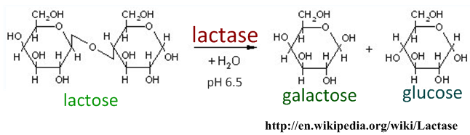
- Describe why simply adding lactose to milk is ineffective.
……………………………………………………………………………………………………………………………..
- Explain the use of immobilized lactase in production of lactose-free milk
……………………………………………………………………………………………………………………………..
……………………………………………………………………………………………………………………………..
……………………………………………………………………………………………………………………………..
……………………………………………………………………………………………………………………………..
- List two other commercial uses of enzymes.

……………………………………………………………………………………………………………………………..

……………………………………………………………………………………………………………………………..

- Explain the lowering of activation energy by enzymes. SKIP this until asked to answer this.
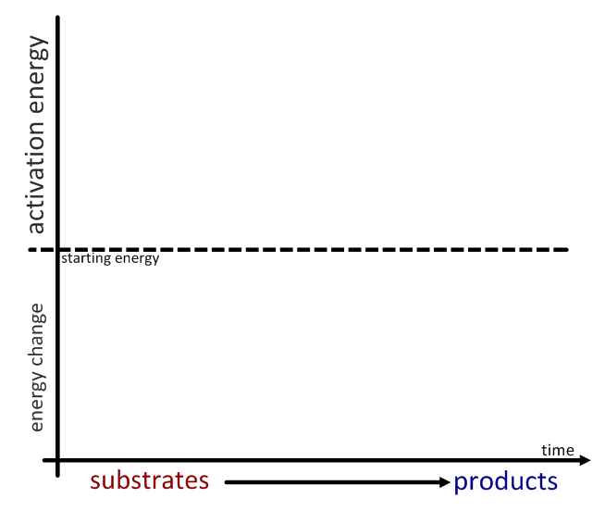

- Describe the induced-fit model of enzyme activity, with reference to conformational change and activation energy.
……………………………………………………………………………………………………………………………..
……………………………………………………………………………………………………………………………..
……………………………………………………………………………………………………………………………..
……………………………………………………………………………………………………………………………..
……………………………………………………………………………………………………………………………..

- A metabolic pathway is a chain or cycle of enzyme-controlled reactions.
  - List two examples of chain pathways.
………………………………………………………………………………………………………..
………………………………………………………………………………………………………..
  - List two examples of cyclical pathways.
………………………………………………………………………………………………………..
………………………………………………………………………………………………………..

- In the space below, draw and annotate diagrams to explain the difference between competitive and non-competitive inhibitors.
Competitive | Non-competitive

- Distinguish between competitive and non-competitive inhibition.
 | Competitive | Non-competitive
Place of action | Active site | Allosteric site
Effect on enzyme |  | Conformational change of active site
Effect on activity |  | Fewer active sites available for reaction
Graph of effect of inhibitor on activity
Therapeutic example | Antabuse is a competitive inhibitor of aldehyde oxidase, which breaks down the toxic intermediate step of alcohol metabolism. It is used in treating alcoholism – if the patient drinks alcohol he/she will feel very ill.

- Explain end-product inhibition of enzyme-controlled pathways as an example of negative feedback control, using E. coli’s control of tryptophan as an example.

