- State the functions of life, as demonstrated by all living organisms.

- Define the following terms, with examples:
Unicellular

Multicellular

Acellular

- State some examples of modern technology that have confirmed cell theory.

- Outline the three fundamental statements of cell theory
i. Cells are the smallest units of life
ii.
iii.
- Outline the significance of the work of these scientists in forming cell theory.
i. Antonie van Leuwenhoek
ii. Robert Hooke
iii. Louis Pasteur and Robert Remak

- Describe how the following examples might be exceptions to cell theory.
a. Muscle cells and fungal hyphae

b. Viruses

c. Amoebae

- Complete this table of SI units of length:
Unit | Abbreviation | Metric Equivalent  Whole scientific notation
kilometer | km | 1 000 m | 10³ m
 | m | 1 m | 1m
centimeter | cm |  | 10⁻² m
 | mm | 0.001 m | 10⁻³ m
micrometer | μm | 0.000 001 m
nanometer | nm |  | 10⁻⁹m
- The diagram below shows the characteristic rod-shaped structure of E. coli bacteria.
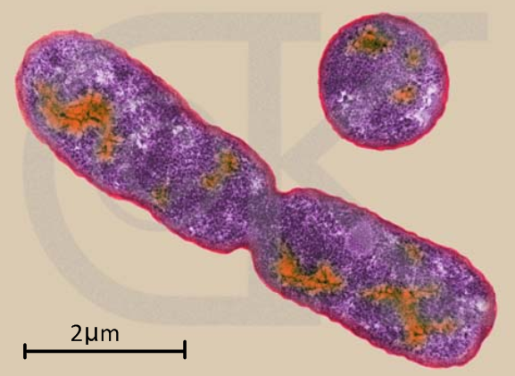
a. Calculate the magnification of the image.

b. State the method (shown here) by which bacteria reproduce.

- Calculate the actual size of the structures delineated in yellow.
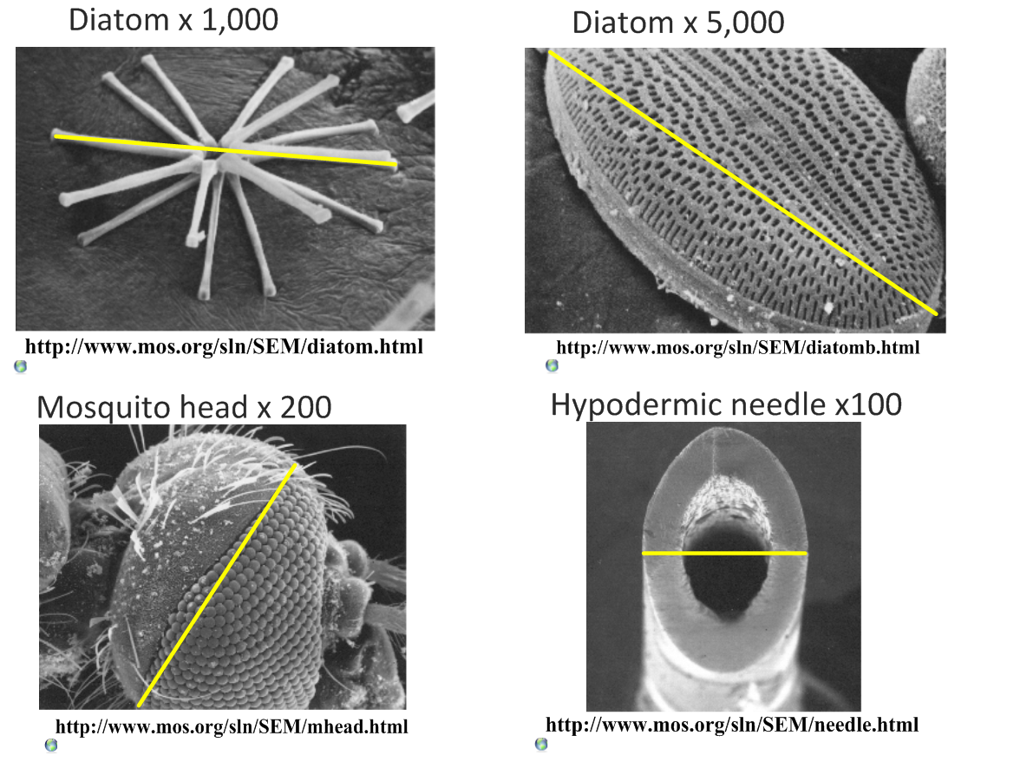

- Calculate the magnification of these scale bars:
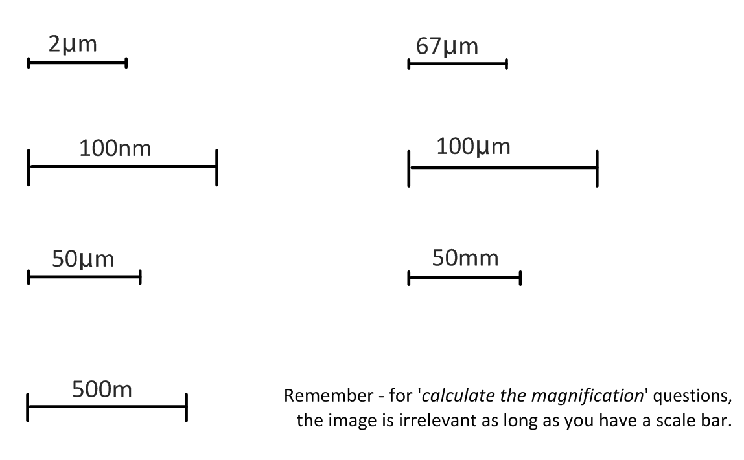
- What is the magnification of these images?

- Scale bar 10µm measures 40mm on the image.

b. Scale bar 5µm measures 25mm on the image.

- A micrograph has a scale bar of 2µm, which measures 40mm on the image. Measuring the maximum length of the cell in the image, the ruler reads 180mm. How long is the cell?

- A student views an image of a cell magnified 350 times. The image is 250mm long. What is the actual length of the sample in the image?

- Compare the sizes of these structures. Use SI units.

Plant cell | Animal cell | nucleus | bacteria | Mito-chondria | virus | ribosome | Membrane thickness | molecules

- Use some of these electron microscope resources to view molecules, cells and structures and to practice calculating magnifications and actual sizes.

Virtual Electron Microscope: http://virtual.itg.uiuc.edu/

Microscopy UK: http://www.microscopy-uk.org.uk/

- As the volume of a cell increases, what happens to…? (increase/ decrease)

- Production of waste products.

- Usage of nutrients and oxygen.

- The surface area: volume ratio.

- State the advantages of maximizing the surface area: volume ratio in a cell.

- List some adaptations used by cells to maximize SA:Vol ratio.

- List some adaptations used by multicellualr organisms to maximize SA:Vol ratio

- Describe how a large SA:Vol ration can be harmful or costly to small animals.

- Describe how the invasive Caulerpa algae genus break the rules of SA:Vol.

- Unicellular organisms carry out all the functions of life, multi-cellular organisms differentiate and show emergent properties. Describe what is meant by the term emergent properties.

