- S.typhi and Escherichia coli are examples of prokaryotes.
- Define prokaryote.

- Draw and label the ultrastructure of a generalized prokaryote. Include cell wall, plasma membrane, pili, flagella, nucleoid (naked DNA), ribosomes and a scale bar.
- State the function of each of the labeled parts.

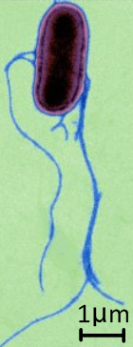
- This is an electronmicrograph of the bacterium Salmonella typhi.

- Calculate the magnification of the image.

- Calculate the length of the cell body.

- State the name and function of this structure.

- State the method by which prokaryote cells reproduce.

- Identify the labeled structures in this diagram and transmission electron micrograph.
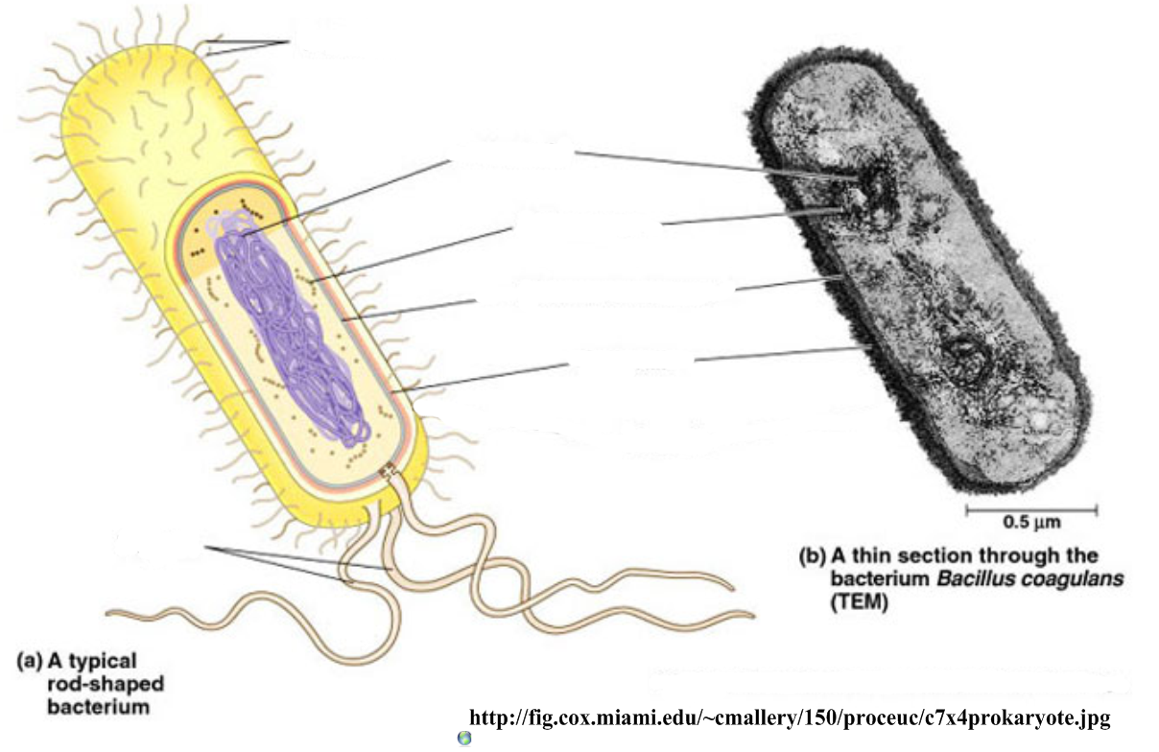

- This image is a transmission electron micrograph of a bacterium.
- Identify the labeled structures
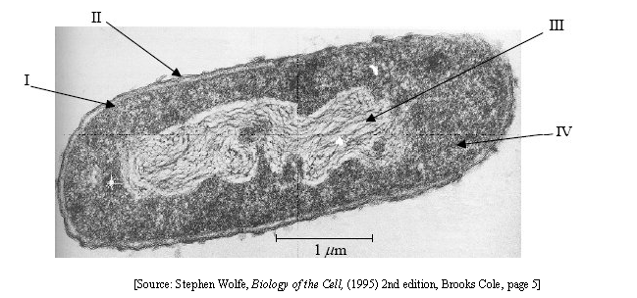
- Calculate:
- The magnification of the image

- The maximum length of the bacterium.

- Plant and animal cells are eukaryotic.
- Define eukaryote.

- Evidence for Cell Theory: Outline the role of Robert Brown in forming cell theory.

- Compare prokaryote and eukaryote cells.

Prokaryote | Eukaryote
70S (small) ribosomes  No mitochondria  Cell parts | 80S (large) ribosomes  True nucleus contains DNA  Organelles in discrete membranes  Internal membranes enclose organelles  10-15µm in diameter

- Compare the structures of plant and animal cells, using clear, labeled diagrams.
Include annotations on the functions of each organelle and scale bars to show size.

- Outline the functions of these eukaryotic organelles:

Organelle | Structure (description) | Function of organelle | Draw it
 | Region of the cell containing chromosomes, surrounded by a double membrane, in which there are pores. | Storage and protection of genetic information on chromosomes.
Ribosome | Small spherical subunit consisting of two subunits, some attached to membranes, others free.
 | Spherical organelles surrounded by a single membrane, containing hydrolytic enzymes. | Digestion of structures ad molecules that are not needed in the cell.
 | Organelles surrounded by two membranes, the inner of which is folded inwards.
 | Double-membrane containing layers of membranes (thylakoid stacks) and the pigment chlorophyll.
 | Large, folding membrane structure found close to the nucleus, with ribosomes attached to some surfaces.
 | Large, folded membrane structure found close to the plasma membrane, often with vesicles budding off the outer edge.

- The image below shows a TEM micrograph of a liver cell.
- Identify the labeled structures.
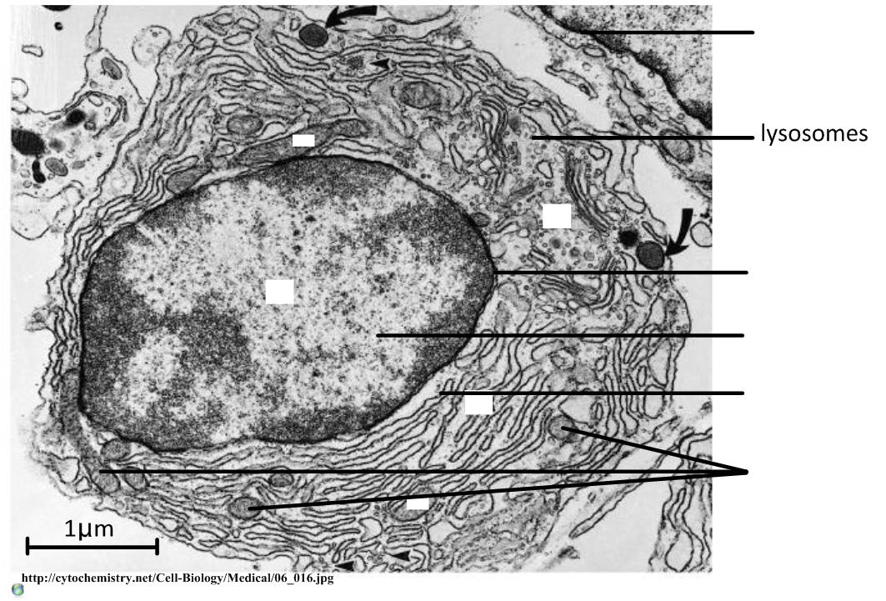

- Calculate the magnification of the image.

- Calculate the maximum diameter of the nucleus.

- Extracellular components are materials or structures which extend beyond the plasma membrane. Outline the role of an extracellular component in a plant cell and an animal cell.

Plant:

Animal:

- Specialised cells are adapted to suit their function.
- In the space below, draw and label three specialized cells (two animal, one plant), outlining the relationship between structure and function in each case.
Diagram | Structure vs function

- Explain how cells differentiate from stem cells to become specialized.

