- Using your notes, the class website and your class textbook, answer the following. Highlight the command term.
- Pick five questions and create original IB type questions indicate how many pieces of information will be required to be given to get full marks/ complete answer.

- Define pathogen.
“An organism or virus that causes disease.” ^{(1 p. 49)}

- List some examples of illness which are pathogenic and non-pathogenic.
Pathogenic:
Non-pathogenic:

- Outline one example of an infection by each of the following types of pathogens:
Type of pathogen | BACTERIA | VIRUS | FUNGI | PROTOZOA
Example disease | Cholera
Pathogen | Vibrio cholerae
Method of transmission | Contaminated drinking water or food
Symptoms | Severe diarrhea and vomiting
Treatment | Urgent oral rehydration, antibiotics
Dangers | Death by dehydration

- Explain why antibiotics can be used to treat bacterial infections but not viruses.

Link thought: how does overuse of antibiotics lead to antibiotic resistance? There are plenty of references to this on the class website
- In the space below, draw and annotate two simple line graphs to distinguish between the action of bacteriostatic and bacteriocidal antibiotics:
Link thought: how does overuse of antibiotics lead to antibiotic resistance?

- Outline the role of skin and mucous membranes in primary defense (acting as barriers against pathogens):
Skin is a tough barrier
Hairs, e.g. nose
Mucous, such as in nose, airways
Acidic conditions (e.g. stomach and vagina)
Lysozymes
Natural organisms

- State the functions of the following components of the blood:
Lymphocytes | Immune response – e.g. B-cells and T-cells
Phagocytic leukocytes (macrophages)
Erythrocytes
Platelets
Plasma

- Outline how phagocytic leukocytes ingest pathogens in the blood and body tissues.
Method of membrane transport:
How does it work?

- Distinguish between antibodies and antigens.

Antibody | A globular protein. (revise levels of protein structure)  Produced as part of the immune response.  Specific to the antigen on the pathogen – the antigen binding site is analogous to the active site of an enzyme.
Link thought: how is this important in ABO blood typing and how is that an example of codominance?
- Explain how antibodies are produced.
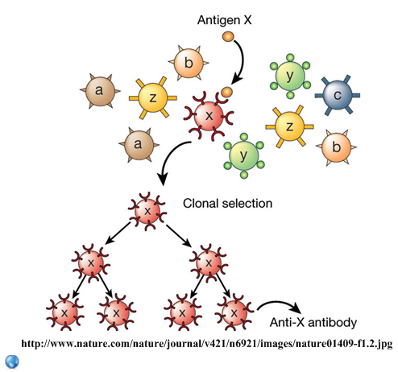 | There are many different types of lymphocytes in the immune system.

Link thought: antibodies are globular proteins produced by lymphocytes. Explain how the final antibody is produced from the genetic information in the lymphocyte nucleus, to a level of detail appropriate to your level of study.

- State the role of memory cells following an infection.

- Define the terms HIV and AIDS
HIV =
AIDS =

- Outline the effects of HIV on the immune system.
Effect on lymphocytes
Effect on antibody production
Effect on health

- Discuss the cause, transmission and social implications of HIV/AIDS.
Cause
Methods of transmission
Social implications

- Outline some of the economic impacts of HIV in the developing world.
- The graph below shows the progression of a typical case of HIV. CD4 cells are those attacked by the HIV virus. Once levels of these lymphocytes drop below a critical value, the immune system is no longer able to fight infection and AIDS is diagnosed.
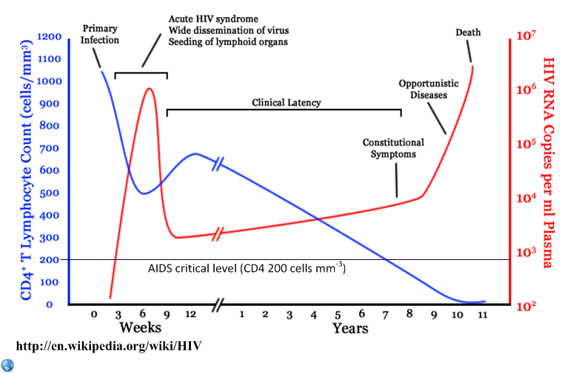
- State the CD4 cell count at which AIDS is likely to be diagnosed.

- Deduce, with a reason, the period in which a person infected with HIV is most likely to pass it on to someone else.

- Describe the effects of HIV on the immune system over time.

- Identify the period in which other illnesses are most likely to result in death.

