- Define pathogen.

- List some examples of illness which are pathogenic and non-pathogenic.
Pathogenic:
Non-pathogenic:

Linked: explain how a pathogenic organism could be identified

- Explain the development of penicillin as a treatment for infectious diseases.

TOK Link: Outline the ethics involved with mice and human testing in the initial trials. What is the
IBO policy on animal experimentation.

- Explain why antibiotics can be used to treat bacterial infections but not viruses

- Explain two ways that antibiotics work in treating a bacterial infection.

- In the space below, draw and annotate two simple line graphs to distinguish between the action of bacteriostatic and bacteriocidal antibiotics:
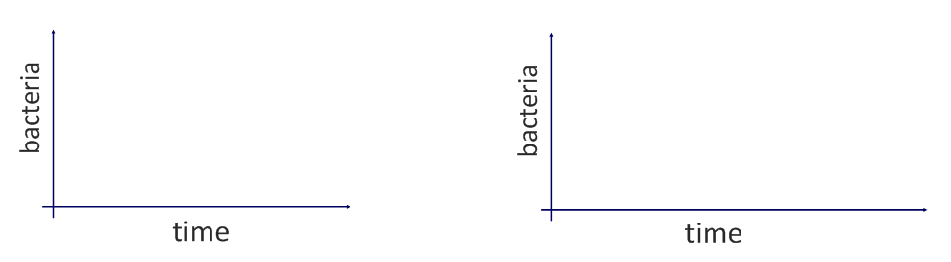
Link thought: Explain how antibiotic resistance develops? Identify specific aspects of prokaryotic cell structures allows for this to occur.

- Outline the role of skin and mucous membranes in primary defense (acting as barriers against pathogens):
Skin
Mucous membranes

Acidic conditions (e.g. stomach and vagina)
Lysozymes

Bacterial flora (external and intestinal)

- State the functions of the following components of the blood:
Erythrocytes
Platelets
Plasma
Leukocytes (white blood cells)
Phagocytes |  |  | Lymphocytes
Macrophages |  |  | B-Cells
 |  |  | T-Cells

- Blood clotting is an example of a metabolic pathway.
Outline the process of blood clotting.

Linked: explain the aspects of enzymes that make it highly beneficial to clotting when injured.

- a. Explain the consequences for thrombosis (clots that are in blood vessels ) on the heart function

Linked b. Cardiac muscle has an extremely high number of mitochondria, compare the outcomes of heart tissue impacted by a thrombosis to healthy heart tissue at the cellular level

Throwback ? coronary heart tissue is muscle fibre- why is this an exception to cell theory

- Outline how phagocytic leukocytes (macrophages) ingest pathogens in the blood and body tissues.
Method of membrane transport:
Explain how this transport works
Describe the qualities in membranes that make this possible

- Distinguish between antibodies and antigens.

Antibody

Antigen
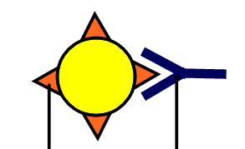
Link The body’s immune system is able to distinguish between self and foreign pathogens. Explain how this is further evidence for the fluid mosaic model of membrane structure

Link: antibodies are globular proteins called immunoglobulins produced by lymphocytes. Describe the structure of this type of protein and identify the types of bonds that are responsible at each level.

- State the role of memory cells following an infection.

- Define active and passive immunity.
Active:
Passive:

- Explain how immunoglobulins are produced.
Use the following terms: pathogen, phagocyte, (antigen), helper T-cell, B-cell, clone, plasma cell, immunoglobulin.
- Pathogen is ingested by a macrophage.

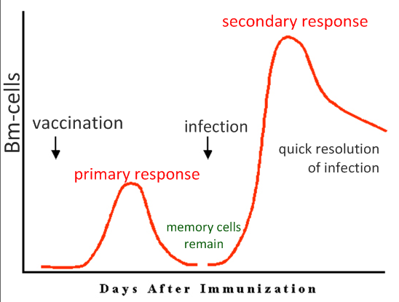
- Explain the principles of vaccination.
- Antigen is introduced to the body

- Define the terms HIV and AIDS

HIV =
AIDS =

- Outline the effects of HIV on the immune system.
Effect on lymphocytes

Effect on antibody production

Effect on health

- Discuss the cause, transmission and social implications of HIV/AIDS.
Cause
Methods of transmission

Explain why no current vaccination possible

20.The graph below shows the progression of a typical case of HIV. CD4 cells are those attacked by the HIV virus. Once levels of these lymphocytes drop below a critical value, the immune system is no longer able to fight infection and AIDS is diagnosed.
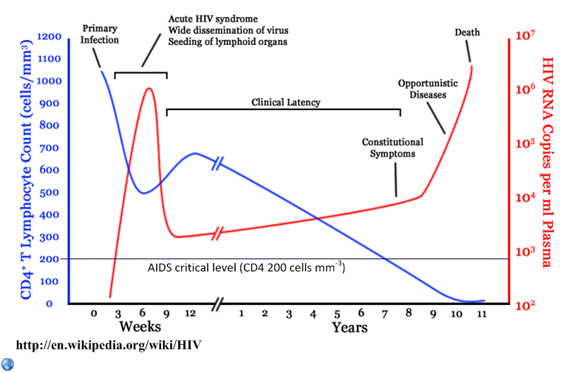
- State the CD4 cell count at which AIDS is likely to be diagnosed.
- Deduce, with a reason, the period in which a person infected with HIV is most likely to pass it on to someone else.
- Describe the effects of HIV on the immune system over time.
- Identify the period in which other illnesses are most likely to result in death.

