- Complete the diagram below concerning animal homeostasis and blood sugar regulation.
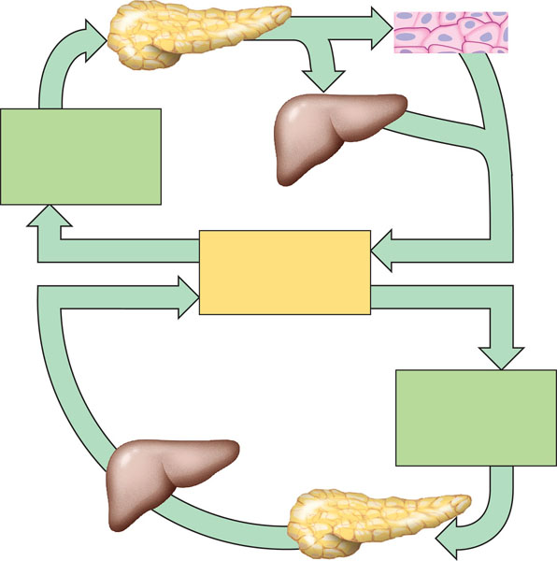
- How do hormones regulate appetite in humans?

- What are essential and non essential nutrients?
- Contrast vitamins and minerals.List two of each and state the name of two deficiencies of each.
- Define the following terms:
  - Ingestion
  - Digestion
  - Enzymatic hydrolysis
  - Absorption
  - Excretion
- Contrast intracellular and extracellular digestion.

- Label and draw the human digestive system.

- What are the accessory glands of the digestive system and why are they call “accessory” – are they part of the digestive tract?
- What is peristalsis?
- Use the diagram below to label and explain the process of swallowing .
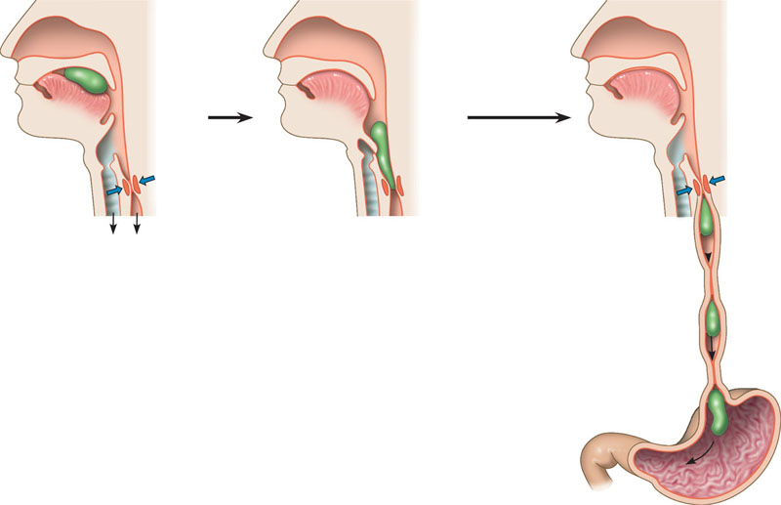

- Describe the first part of the small intestine – what activity is occurring here?

- What is bile – explain where it is produced, stored and what its chemical action is?

- Explain the enzymatic digestion of the three macromolecules ( proteins, fats and lipids) Describe the conditions for optimal ph of these enzymes. State the classes of enzymes responsible.

- Explain the structure/function relationship does the body control the absorption of nutrients in the small intestine?

- Explain the route for fat absorption. Include a diagram and the structure/function relationship of the intestinal structures responsible.

- Explain the role the liver plays in homeostasis with regard to digestion

- Explain the major function that the large intestine has in the digestive process

