Blog resource: http://tinyurl.com/4ckten2 Click4Biology: http://tinyurl.com/4ek7thd
Cite all sources using the CSE method (or ISO 690 Numerical in Word). The first example has been done for you. Highlight all objective 1 command terms in yellow and complete these before class. Highlight all objective 2 and 3 command terms in green – these will be part of the discussions in class. After class, go back and review them.
Complete the self-assessment rubric before submitting.
- Define photosynthesis
The conversion of ________________________ into _______________________ in plants. ^{(1 p. 65)}
- Write a word equation and balanced symbol equation for the process of photosynthesis.
Word:

Symbol

- Glucose is a product of photosynthesis. It can be used directly in respiration, stored as starch or converted to glucose.
- Distinguish between the functions of starch and cellulose.

Starch:

Cellulose:

- Identify and outline the process of condensation to form a disaccharide.

- Explain why a plant which is left in the dark for a long period of time will test negative for starch.

- Light from the Sun is composed of a range of wavelengths (colours).
- Outline the properties of these wavelengths of light:
Wavelength (nm) | 10-400 | 400-500 | 500-650 | 700-800 | 0.8-1000µm
Name | Ultraviolet |  |  |  | Infra-red
Photosynthesis? | No |  |  |  | No
Visible? | No | Yes | Yes | Yes | No
Energy | Very High |  |  |  | Low
Frequency | Very High |  |  |  | Low

- State the name of the photosynthetic pigment and its location in green plants.
Name: ________________________ Location: ______________________________

- Distinguish between action and absorption spectra for photosynthesis.
Action:
Absorption:

- Use the spreadsheet here to produce action spectrum for photosynthesis and absorption spectrum for chlorophyll: https://www.box.net/shared/cs6jvzv8n4

- In the space below, draw a graph showing the action and absorption spectra for chlorophyll. Annotate the diagram to show why leaves appear green.
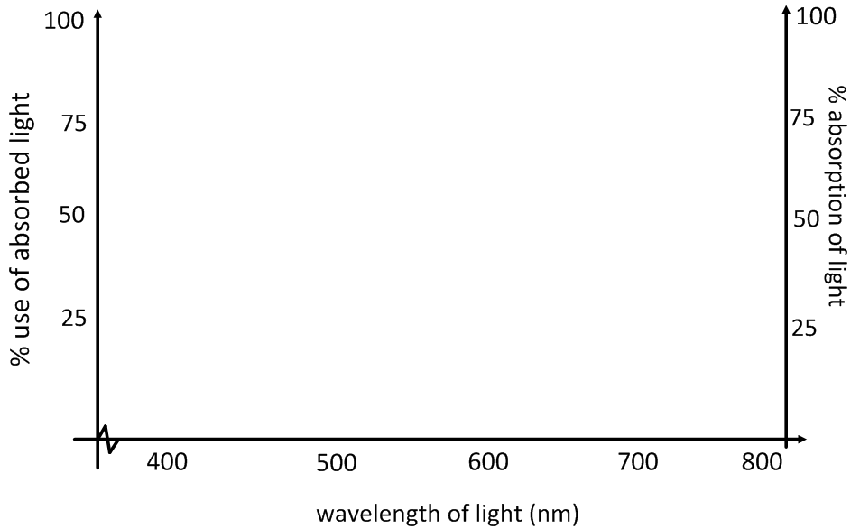

Leaves appear green because…
- Summarise the two main stages of photosynthesis:
 | Input | Outcome
Light-dependent reactions | Light energy is used to…
Light independent reactions

- Define rate, with regard to reactions.

- Explain how the rate of photosynthesis can be measured directly and indirectly.
Direct Measurement 1 |  | Product:
Explanation:

Direct Measurement 2 |  | Product:
Explanation:

Indirect Measurement |  | Outcome:
Explanation:

- Outline the effects of the following variables on the rate of photosynthesis.
Sketch and annotate a graph for each one.

Light intensity
Note: light intensity is not the same as wavelength or frequency. Light intensity refers to the amount of light of a given wavelength which is available to the plant. Light intensity is high at the equator, in the summer or at midday.
Temperature
Carbon dioxide concentration

Works Cited
1. IBO. Biology Subject Guide. [Online] 2007. http://xmltwo.ibo.org/publications/migrated/production-app2.ibo.org/publication/7/part/2/chapter/1.html.
2. Allott, Andrew. IB Study Guide: Biology for the IB Diploma. s.l. : Oxford University Press, 2007. 978-0-19-915143-1.
3. Mindorff, D and Allott, A. Biology Course Companion. Oxford : Oxford University Press, 2007. 978-099151240.
4. Clegg, CJ. Biology for the IB Diploma. London : Hodder Murray, 2007. 978-0340926529.
5. Campbell N., Reece J., Taylor M., Simon. E. Biology Concepts and Connections. San Fransisco : Pearson Benjamin Cummings, 2006. 0-8053-7160-5.
6. Taylor, Stephen. Science Video Resources. [Online] Wordpress, 2010. http://sciencevideos.wordpress.com.
7. Burrell, John. Click4Biology. [Online] 2010. http://click4biology.info/.

Self Assessment:
 | Essential Biology |  |  | Assessment
Criterion | Complete (2) | Partially complete (1) |  | Self | MrT
Presentation & Organisation | NA | Complete and neat. All command terms highlighted, tables and diagrams well presented.
Academic Honesty | NA | Sources cited using the CSE (ISO 690 numerical) method, with Works Cited section complete and correct.
Objective 1 understanding | All answers for the following command terms correct: | Most answers for the following command terms correct:
 | Define Draw Label List Measure State
Objective 2 understanding | All answers for the following command terms correct: |  | Most answers for the following command terms correct:
 | Annotate Apply Calculate Describe Distinguish Estimate Identify Outline
Objective3  understanding | All answers for the following command terms correct: |  | Most answers for the following command terms correct:
Analyse Comment Compare Construct Deduce Derive Design Determine Discuss
Evaluate Explain Predict Show Solve Sketch Suggest
Logic, notation, mathematical working | NA | Answers are presented in a logical and concise manner. SI units used most times, with correct unit symbols and definitions of terms. All mathematical working shown.
Further research | NA | Evidence is apparent of research and reading beyond the textbook and presentations to find correct answers to challenging questions. If any questions are unanswered, this criterion scores zero.
 | Total (max 10):

