- Define the following:
Gamete | Haploid sex cell, which fuses with another gamete in fertilization. Sperm and eggs. ⁽¹⁾
Oogenesis
Spermatogenesis
Fertilisation
Gestation

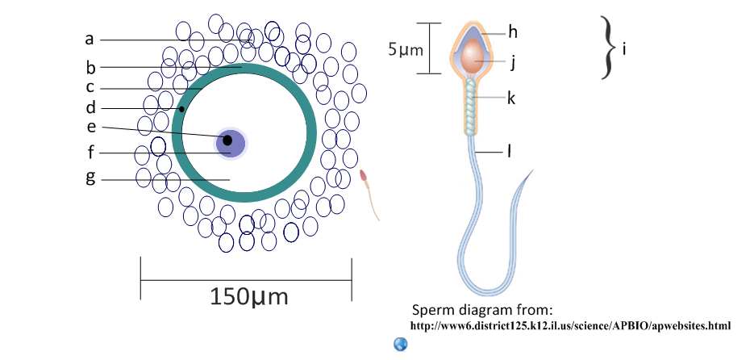
- Label the structures of the mature sperm and egg and calculate the magnification of each image.
a | follicle cells | h
b |  | i | head
c |  | j
d |  | k
e |  | l
f |  | Magnification:
g
Magnification:
- Label this diagram of the male reproductive system.
a | vas deferens | 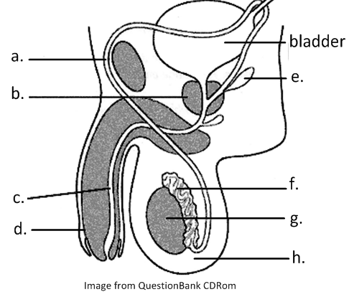
b
c
d
e
f
g
h

- Annotate this light micrograph of testis tissue.
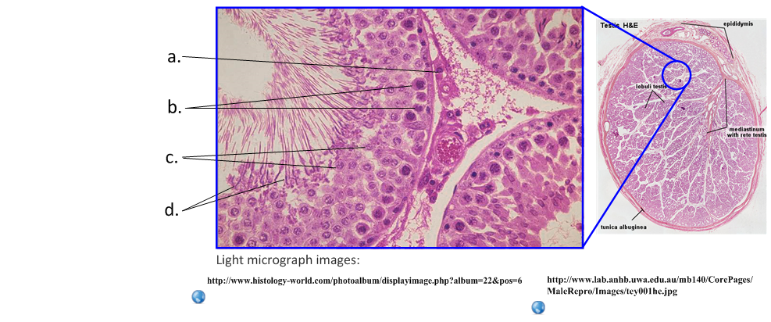
a | interstitial cells
produce testosterone.
b
c
d

- State the roles of the following hormones in spermatogenesis.
Luteinizing hormone (LH)
Testosterone
Follicle stimulating hormone (FSH)

- State three other roles of the male sexual hormone testosterone.

- Outline the process of spermatogenesis in the testes.
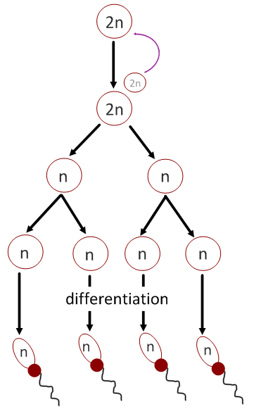

- Outline the role of the following structures in semen production.
epididymis
seminal vesicle
prostate gland

- Label this diagram of the female reproductive system.
Annotate each structure with its function.
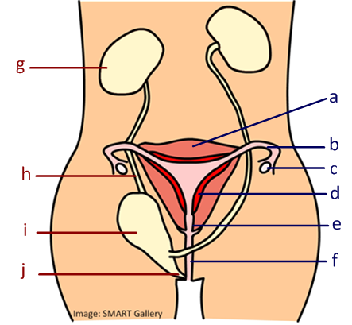 |  |  |  |  | - uterus
 |  |  |  |  | Muscular womb for development of fetus
Name these structures:
g | kidney | h |  | i |  |  | j

- Label and annotate these structures of the ovary.
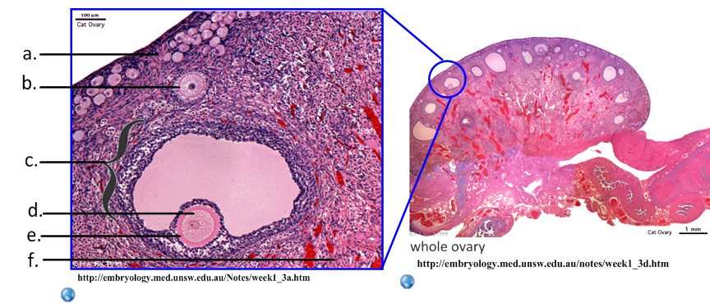
a | germinal epithelium
Constant mitosis produces primary follicles.
b
c
d
e
f
- Outline oogenesis.
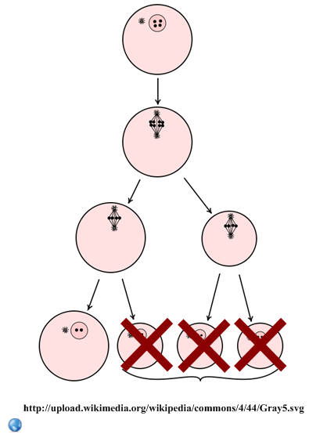

- Compare spermatogenesis and oogenesis.
 | Spermatogenesis | Oogenesis
Number of gametes produced per primary cell
Formation of gametes | Constant after puberty
Number of meiotic divisions
Method of release of gametes |  | Ovulation, controlled by LH
Number of gametes released | Millions
Hormones used
Location

- Outline the roles and origins of these menstrual cycle hormones.
Follicle Stimulating Hormone (FSH) | Origin: pituitary gland (brain)
Role:
Luteinzing Hormone (LH) | Origin:
Role:
Oestrogen | Origin: ovary
Role:
Progesterone | Origin:
Role:

- State the role of these two hormones in the female reproductive system.
HCG:
Oxytocin:

- Deduce the hormones and events required to complete this concept map.
You may print this page.
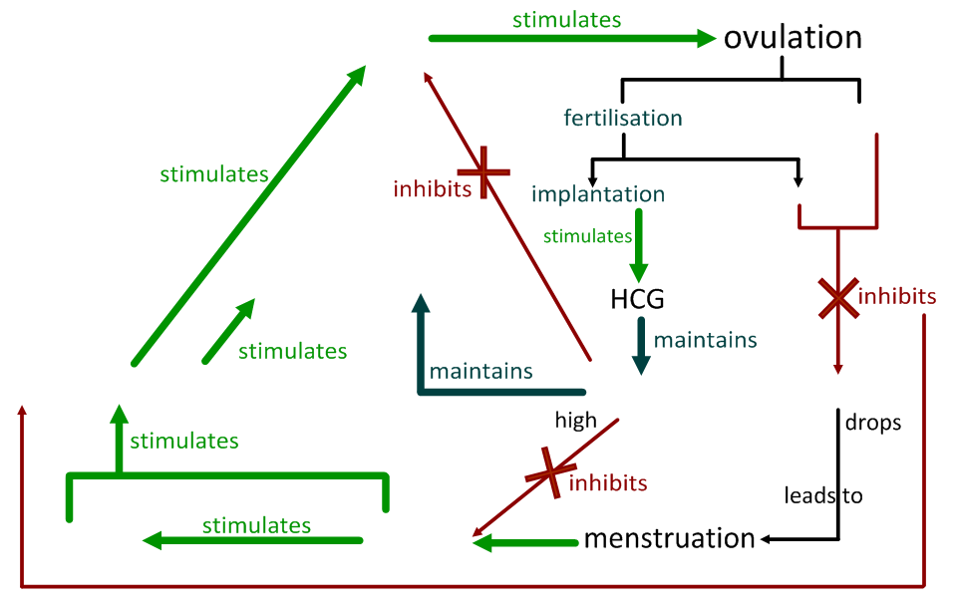

- The graph below shows the human menstrual cycle.
- Sketch the changes in the endometrium over the cycle.
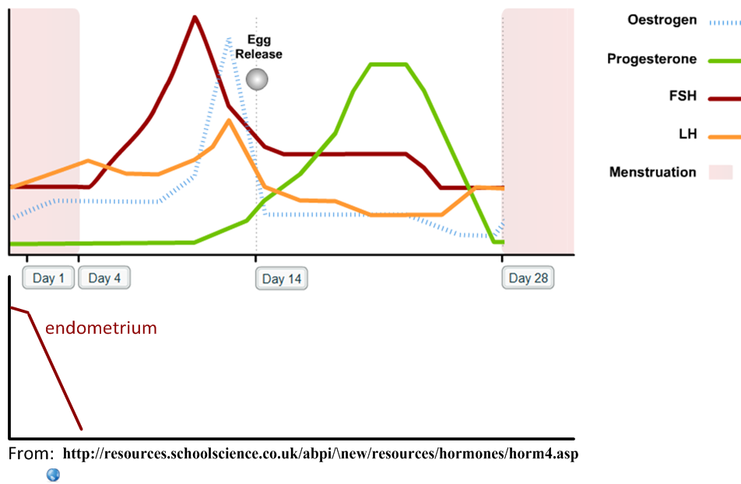

- Outline the events of the menstrual cycle, including the roles of the various hormones.
1-4 Days |  | Follicular phase
Events:
5-14 Days |  | Ovulatory phase
Events:
14-28 Days |  | Luteal phase
Events:

- Distinguish between fertilization and pregnancy.

- Describe the process of fertilization of an egg by a sperm.
acrosome reaction

- The contraceptive pill manipulates the hormones of the menstrual cycle in order to prevent unwanted pregnancy.
- The combined pill contains oestrogen and progestin (a synthetic form of progesterone). Explain how this combination might prevent pregnancy.

- The package of pills usually contains 21 pills of the hormone and 7 ‘placebo’ pills. These placebo pills can contain an iron supplement. Deduce the function of these pills.

- The ‘rhythm method’ is used in family planning and contraception.
Identify the days of the cycle during which a woman is:
- Most likely to conceive

- Least likely to conceive.

- Evaluate the following methods of contraception.
Effectiveness for… | Contraception | Protection against STI’s
Oral contraceptive pill
Rhythm method
Condoms

- Outline the process of in-vitro fertilisation.
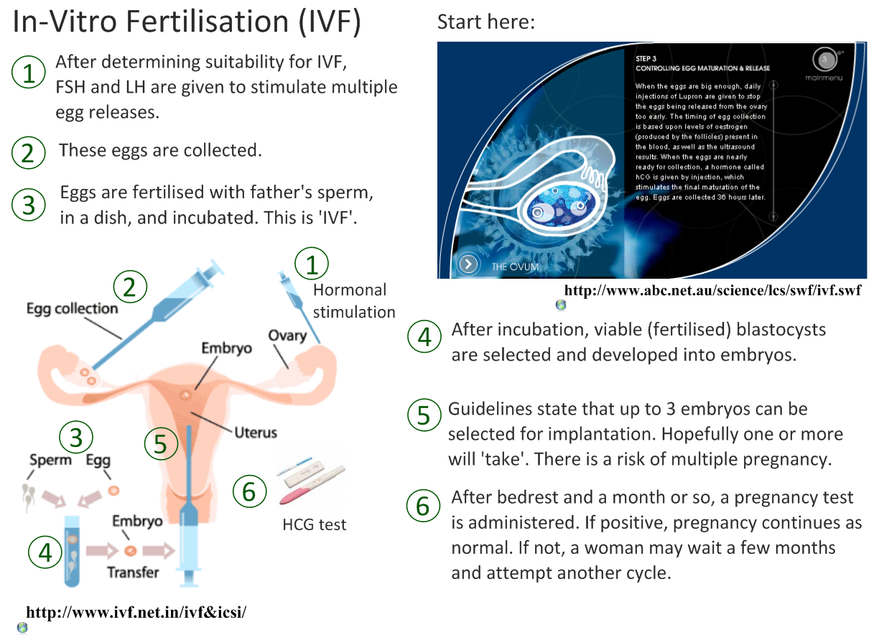 | 1 | FSH and LH are given in high doses to the potential mother in order to stimulate production of multiple ova.
 | 2
 | 3
 | 4
 | 5
 | 6

- Discuss the ethical issues of IVF.
Arguments for | Arguments against

Reading: IVF Wins Nobel Prize for Medicine 2010! http://nobelprize.org/nobel_prizes/medicine/laureates/2010/press.html

- HCG is released early in the pregnancy if a blastocyst implants on the endometrium.
- State the origin of HCG.

- Outline two functions of HCG in early pregnancy.
Function |  | Advantage
Inhibits… | FSH and LH
Maintains…

- HCG can be detected in the urine. Identify the type of immune system molecule used to detect HCG in pregnancy kits.

- State the method used to produce these molecules for the test kits.

- Early embryonic development.
- State the method of cell division used in embryonic development.

- Outline the events leading up to implantation of the blastocyst on the endometrium.

- The developing fetus is protected and served by the placenta, amniotic sac and umbilical cord.
State the function of the amniotic sac and fluid. | 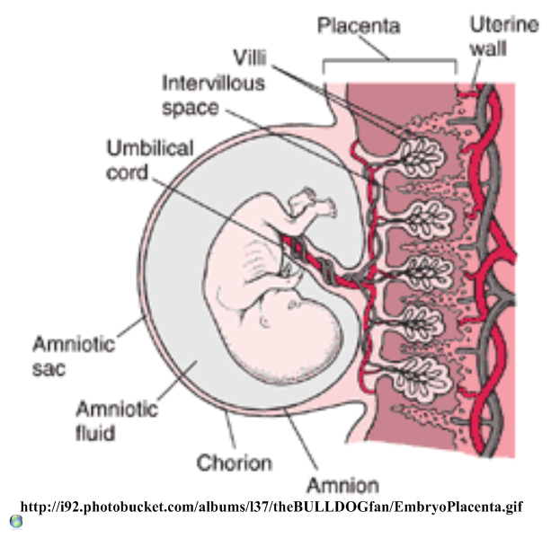
Identify the hormones released by the placenta.
List the materials exchanged between the fetal and maternal blood.
Mother to fetus:

Fetus to mother:

- Explain how the following structures of the placenta aid its function.
Umbilical cord
Villi
Inter-villus spaces
Blood supply
Membrane
Rough endoplasmic reticulum in cells

- Birth is controlled by positive feedback mechanisms in the body, which is in contrast to the negative feedback mechanisms of homeostasis.
- State the name of the ‘birth hormone’.

- Explain why regulation of this hormone is classed as positive feedback control.

- Outline the process of birth and its hormonal control.
  - Progesterone levels drop
  - Fetal head engages in cervix

Links across the syllabus:
- How do sexual reproduction and meiosis ensure variation in the population?
- How does the oxygen in the maternal blood get into the fetal blood?
- What similarities are there between the structures of the placenta and other human body systems?
- How are twins produced and how does polygenic inheritance lead to variation in some characteristics (e.g. skin colour) between non-fraternal twins?
- How does gene expression lead to differences in the phenotypes of fraternal twins, despite their sharing DNA?
- What is prenatal testing and how is it applied in pregnancy?
- What are the risks of late-age pregnancy?

How many more links across the syllabus can you find and explain?

