- Define the following terms:as they directly relate to ecology ( Not Econ!)
Gross production:

Net production

Biomass

- Explain why gross production is always higher than net production.

- State the calculation for determining gross production, net production and respiration.

- The following passage outlines some of the energy flow in an ecosystem.
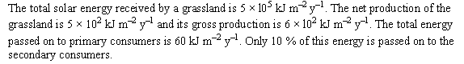
From the IB Biology QuestionBank CDRom

- Calculate the efficiency (in %) of the conversion of light energy into gross production.

- Draw a pyramid of energy for the ecosystem.

- Explain the shape of the pyramid of energy.

- Study the energy flow diagram below.
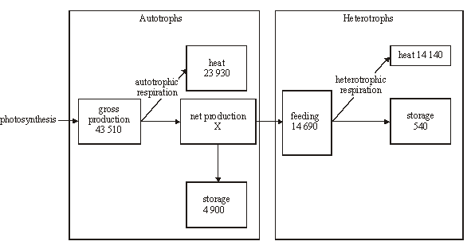
From the IB Biology QuestionBank CDRom
- Calculate the net production of the autotrophs.

- Calculate the percentage of energy lost as heat in:

- Autotrophs

- Heterotrophs

- Suggest reasons for the differences in energy loss as heat between autotrophs and heterotrophs.

- Discuss the difficulties of classifying organisms into trophic levels.

- Explain the small biomass and low numbers of organisms in higher trophic levels.

- Discuss how the high-meat diet of the developed world (which is aspired to by many developing nations) may be speeding our approach of the planet’s carrying capacity for humans, and some of the steps that can be taken to reduce this effect.

