Topic 11.3 The Kidney
11.3.1 Define excretion.
Excretion | Excretion is the removal from the body of the waste products of metabolic pathways.

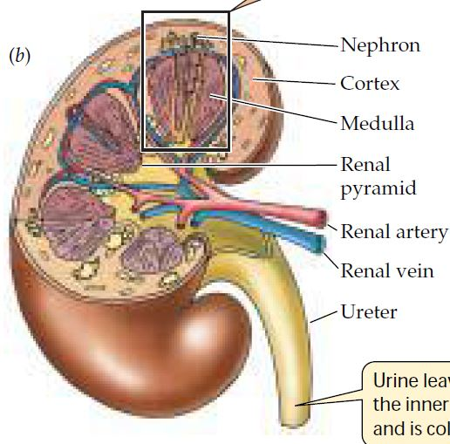
11.3.2 Draw and label a diagram of the kidney.
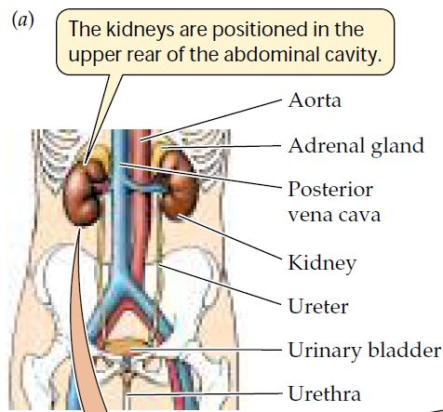
(Diagrams adapted from Life- The Science of Biology by Purves, Sadava, Orians, & Heller, 7th ed., W.H. Freeman 2004)
State the name of each lettered structure above, and outline its function. Use: renal pyramid, renal artery, renal vein, cortex, medulla, nephron, & ureter.
A) Nephron | The functional unit of the kidney where the blood is filtered
B) Cortex | The outer portion of the kidney where the glomerulus and Bowman’s capsule (together called the malphagian body), the proximal and distal convoluted tubules, and the upper part of the collecting ducts are located. Thus, ultra-filtration and most reabsorption happens in the cortex.
C) Medulla | The darker red inner region of the kidney that holds the loop of Henle and the lower part of the collecting ducts. Reabsorption of water and salts happens in the medulla.
D) Renal pyramid | Triangular regions of the medulla where collecting ducts come together
E) Renal artery | takes blood to kidney
F) Renal vein | takes blood away from kidney
G) Ureter | A tube from that carries the urine from the kidneys to the urinary bladder.

Nephron diagram
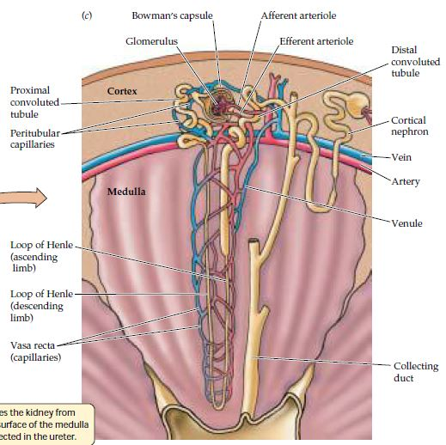

(Diagram adapted from Life- The Science of Biology by Purves, Sadava, Orians, & Heller, 7th ed., W.H. Freeman 2004)

State the name of each lettered structure above, and outline its function. Use: glomerulus, Bowman’s capsule, proximal convoluted tubule, afferent arteriole, efferent arteriole, ascending Loop of Henle, descending Loop of Henle, distal convoluted tubule, & collecting duct
I) Proximal convoluted tubule | Most reabsorption of glucose, salt, and water takes place here
J) Glomerulus | Ultra-filtration
K) Bowman’s capsule | receives filtrate from glomerulus
L) Afferent arteriole | takes blood to glomerulus
M) Efferent arteriole | takes blood away from glomerulus
N) Distal convoluted tubule | reabsorption of salt
O) Collecting duct | reabsorption of urea  reabsorption of salt  reabsorption of water  regulated by ADH
P) Loop of Henle (descending limb) | Reabsorption of water
Q) Loop of Henle (ascending limb) | Reabsorption of salts

11.3.3 Annotate a diagram of a glomerulus and associated nephron to show the function of each part.
Annotate the diagram below with the terms afferent arteriole, efferent arteriole, proximal convoluted tubule, loop of Henle, distal convoluted tubule, & collecting duct.
Distal convoluted tubule is the site of salt reabsorption
Proximal convoluted tubule is the site of most reabsorption of salt, water, & glucose
Efferent arteriole brings blood away from the glomerulus
Afferent arteriole brings blood to the glomerulus

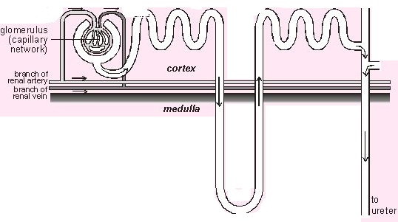

Collecting duct reabsorbs water, salt, and urea and is controlled by ADH. Higher ADH leads to more reabsorption of water & more concentrated urine.
(diagram from www.biologymad.com)
Loop of Henle is selectively permeable to water and salts. Water and salt is reabsorbed here.

11.3.4 Explain the process of ultrafiltration, including blood pressure, fenestrated blood capillaries and basement membrane.
State what fenestrated blood capillaries are. Capilaries that are very porous so that blood may be ultra-filtered- all small molecules (water, glucose, & salt ions) may pass through as filtrate.
Compare the afferent arterioles to the efferent arterioles.
 | Afferent arterioles | Efferent arterioles
Position | Before glomerulus | After glomerulus
Blood pressure | Relatively high due to larger diameter than efferent vessels | Lower due to smaller diameter
Role in ultrafiltration | Higher blood pressure helps to push the filtrate out of the fenestrated capillaries, through the basement membrane, and into the Bowman’s capsule. | Takes filtered blood to the renal vein.

Outline the position & function of the basement membrane. Located between capillary bed of glomerulus and Bowman’s capsule. Not porous which prevents blood cells and large molecules such as proteins from passing through. Acts as a filter that only allows water and small molecules to pass through.

Explain the process of ultrafiltration.
- Osmoregulation takes place in the glomerulus.
- Afferent vessels bring blood to the glomerulus; efferent vessels bring filtered blood away from glomerulus.
- Afferent vessels have larger diameter than efferent vessels, which makes the pressure high in the glomerulus.
- Capillaries in the glomerulus are fenestrated which allows plasma to pass through.
- Basement membrane allows small molecules such as water, salts, ions, glucose, urea, and amino acids to pass into Bowman’s capsule, which surrounds glomerulus. Blood cells and large molecules (proteins) cannot pass.
- All blood in the body is filtered once every 5 minutes.
11.3.5 Define osmoregulation.
Osmoregulation | The regulation and control of the water balance of the blood, tissue and cytoplasm of a living organism.

11.3.6 Explain the reabsorption of glucose, water and salts in the proximal convoluted tubule, including the roles of microvilli, osmosis and active transport.
Water is reabsorbed in the proximal convoluted tubule (PCT). State the approximate percent of water that is reabsorbed from the filtrate in the PCT. About 80%
State two other substances that are also reabsorbed from the filtrate in the proximal convoluted tubule. What percent of those substances are absorbed? Glucose, amino acids, salt, vitamins
Outline the function of microvilli, osmosis, and active transport in the PCT.
Microvilli | Increase surface area to allow more reabsorption to happen
Osmosis | Solute concentrations are higher outside the PCT than in, which makes water move out in osmosis
Active transport | Ions are actively transported out of the PCT, which creates a concentration gradient and drives osmosis. Active transport requires energy, so there are many mitochondria in PCT.

11.3.7 Explain the roles of the loop of Henle, medulla, collecting duct and ADH (vasopressin) in maintaining the water balance of the blood.
ADH (antidiuretic hormone) is a globular protein produced in the posterior pituitary gland. Define diuretic: A substance that promotes the excretion of urine. Antidiuretic means that less urine is produced.
Define hormone: chemical messenger produced by endocrine cells and transported by blood
Annotate the diagram to show the movement of water and ions in each part of the loop of Henle and collecting duct. Label the ion concentrations of both the filtrate in the loop of Henle, the collecting duct, and the fluid in the medulla.
Medulla
Descending limb
Ascending limb
Collecting duct
(if ADH)
H₂O
lower solute concentration
Ascending limb is impermeable to water. Salt is pumped out of the nephron, which increases solute concentration in the medulla.
salt
H₂O
Collecting duct becomes more permeable to water in presence of ADH, which causes water to leave urine and make urine more concentrated.
urea
urea
H₂O
Descending limb is impermeable to salt. Increasing solute concentration in the medulla causes water to leave by osmosis
salt
salt
salt
H₂O
urea
salt
H₂O
H₂O
Higher solute concentratino

Describe the permeability (the state or quality of a membrane that causes it to allow liquids or solutes to pass through it) of the loop of Henle to water and to salt ions.
Water: Descending limb is permeable to water but not salt. Ascending limb is impermeable to water, but permeable to salt, which is pumped out. This causes the medulla to become saltier as it goes deeper.
Define countercurrent exchange: a design in which an element of a liquid such as heat or a solute passes a liquid flowing in one direction to another which is flowing in the opposite direction. It helps to maintain concentration gradients and thus the rate of exchange.
Explain how a countercurrent exchange is established between the medulla and loop of Henle and how it contributes to the maintenance of water balance in the blood.
- The loop of Henle is permeable to water but impermeable to salt in the descending limb. This makes the urine hypotonic, driving osmosis.
- The loop of Henle is impermeable to water but permeable to salt in the ascending limb. This keeps water in the urine making it hypotonic.
- As water leaves the descending limb the urine becomes more concentrated
- Salt leaving the ascending limb makes the medulla salty

Explain the role of the collecting duct (CD) and ADH (vasopressin) in controlling the water balance in the blood.
- Concentration gradient between the medulla & urine (hypotonic) in the collecting duct removes water by osmosis
- ADH is secreted by the pituitary gland, which is controlled by the thalamus.
- ADH receptors in the CD cause pores in the CD to open, which allows more water to leave the urine and make urine more concentrated (conserves water in body). So increasing ADH decreases amount of water in urine.
11.3.8 Explain the differences in the concentration of proteins, glucose and urea between blood plasma, glomerular filtrate and urine.
State the concentrations of proteins, glucose, and urea in the blood plasma, glomerular filtrate, and urine.
 | Concentration (mg / 100ml)
 | Blood plasma | Glomerular filtrate | Urine
Protein | 740 | 0 | 0
Glucose | 90 | 90 | 0
Urea | 30 | 30 | 1200
Explain the differences in concentrations seen in the table above.
- Protein: Protein molecules are too large to pass from the blood plasma to the glomerular filtrate.
- Glucose: Glucose is filtered from the blood plasma, but is reabsorbed in the proximal convoluted tubule
- Urea: Urea is found in the blood plasma as a waste product. It is filtered from the blood in ultrafiltration. Through the reabsorption of other substances needed by the body, the urine becomes highly concentrated with urea.

11.3.9 Explain the presence of glucose in the urine of untreated diabetic patients.
Outline the reason why the urine of non-diabetics does not contain glucose.
Although glucose is filtered out of the blood in ultrafiltration, 100% is normally reabsorbed in the proximal convoluted tubule in non-diabetics.
Briefly describe diabetes.
Type 1: The body does not produce insulin, the hormone responsible for controlling glucose levels in the blood. Usually diagnosed in young people.
Type 2: The body does not use insulin properly. About 95% of diabetes cases are type 2.
Outline the effect of diabetes on the blood glucose level and on glomerular filtrate.
- Diabetics are often hyperglycemic (high blood glucose)
- Glucose is filtered out of the blood in ultrafiltration.
- Increased blood glucose results in increased glucose level in glomerulur filtrate.

Outline the effect of the above on the reabsorption of glucose in the proximal convoluted tubule.
- Increased glucose level in glomerulur filtrate
- Proximal convoluted tubule is site of glucose reabsorption
- If too much glucose in filtrate, PCT will be unable to reabsorb all glucose
- Some glucose will pass into the urine

